Lancement Deski

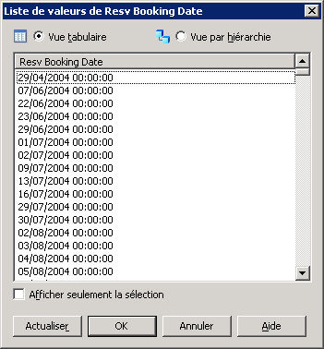

Lancement Webi

