Le schema de ma base

Le code

select count(*), r.identifiant,r.libelle,i.date, i.titre, i.id
, m.libelle, m.iditem, me.id, m1.libelle as detail_type_doc
,m1.iditem as id_detail_type_doc, (select count(m1.iditem ) from metadatalang as m1 ) nbre_contribution_forum from metadatalang as m
left join metadatalang as m1 on m.iditem<>m1.iditem
left join metadata as me on m.iditem= me.id
left join reseau as r on me.idreseau =r.id
left join itemforum as i on r.id= i.idreseau
where r.id=9
and m.iditem in (select distinct(iditem )from metadatalang where iditem='183')
and m1.iditem in( '184','185','3438','186','187','188','189','190','191','192','193')
and date between '[2001-03-29 11:46:42]' AND date '[2002-02-11 21:04:46]'
group by r.identifiant,r.libelle,i.date, i.titre, i.id , m.libelle, m.iditem, me.id, m1.libelle,m1.iditem
order by m1.iditem asc;

le resultat
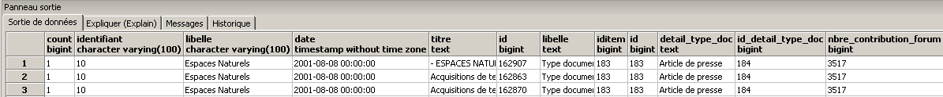
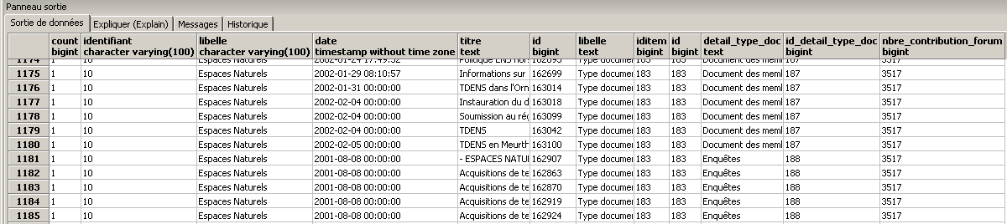
C’est tous le temp le meme resultat , je veux que chaque id_detail_type ait sa somme tatale. La j’ai un seul reseau 10 (espace naturels).

